Title: | Window lifter  SW Component < 1.0 >

History
Issue status | Maturity/Date | Author | Check/Release | Description
1.0 | Draft  31-0ct-2015 | Oswaldo García Cervantes | Oswaldo García Cervantes | Add definitions and abbreviations and add functions in point 5, 5.1, 5.2 and 5.3

Table of Contents
1 Purpose 3
2 Definitions and abbreviations 3
3 Realization constraints and targets 3
4 SW Conceptual design 3
5 SW Component internal breakdown 4
5.1 Functional Decomposition 4
5.2 Function <Type> <function name> (type par 1, .., type par n) 5
5.3 Function <Type> <function name> (type par 1, .., type par n) 5

Purpose
Window lifter is a module that controlees the movement of a window. The module works with two switches that indicate the direction of the movement.
The window will be emulated using a 10 led bar.

Definitions and abbreviations
Definitions

MCU | Word short to Microcontroller
LED | Light – emitting diode is a two-lead semiconductor light source
GPIO | Input and output in the MCU
STM | Timer of MCU
Interruption | Interruption of MCU
LED1 | Bar Led_1 PA[0]
LED2 | Bar Led_2 PA [1]
LED3 | Bar Led_2 PA [2]
LED4 | Bar Led_2 PA [3]
LED5 | Bar Led_2 PA [4]
LED6 | Bar Led_2 PA [5]
LED7 | Bar Led_2 PA [6]
LED8 | Bar Led_2 PA [7]
LED9 | Bar Led_2 PA [8]
LED10 | Bar Led_2 PA [9]
LED_Green | Led green PA[10]
LED_Blue | Led blue PA[13]
S1 | Switch_1 PE[1]
S2 | Switch_2 PE[2]
S2_Antipinch | Switch_3 PE[3]
Open_window(); | Function for on bar leds
Close_window(); | Function for off bat leds
State_buttons(); | Function for switches
led_sysclk_init_fnc(); | Function for initialize leds
Delay(); | Function of delay

Abbreviations

MCU: Microcontroller
STM: System timer reference
Msec: Millisecond

References
N° | Document name | Reference
1 | Traceability Matrix Template
2 | Window-lifter-requirements-Classification-
3 | Bolero_1.5M_FSL_RM_Rev7_2.pdf
4 | Test Plan
5 | variables_naming_rule
6 | SW_C_Code_Review_Template

Realization constraints and targets

The project will be implemented with Bolero architecture, therefore is limited to the characteristics and their components of this board.

Design prototype test

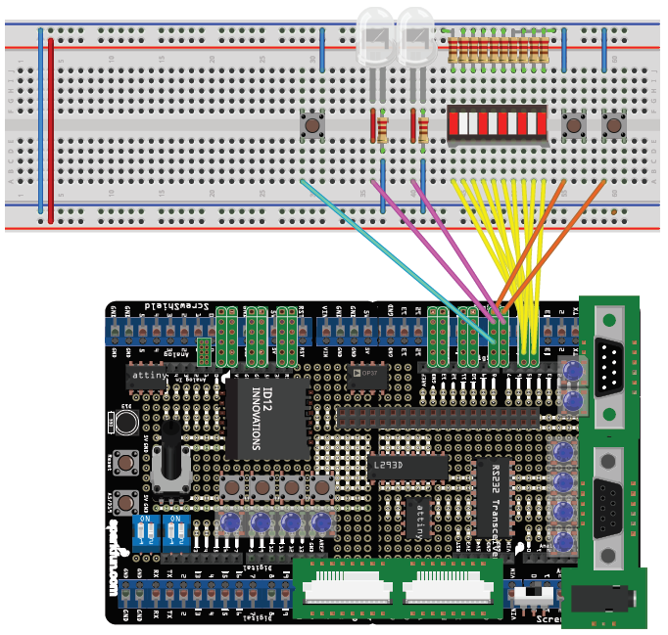

Prototype design elaboration

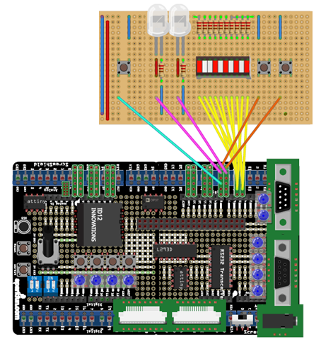

SW Conceptual design
To make a conceptual design identify the product functions and the programs parts needed to produce them.
- Identified all relevant parts in a system or sub-system.
- Define which parts are inside & outside the system boundary
- Define de interfaces between these parts, but also interfaces with neighboring systems and environment.

*Use diagram (User & Programmings)

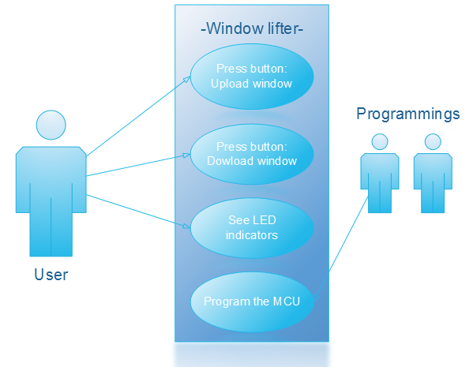

*Use diagram (Programmings & Bolero card)

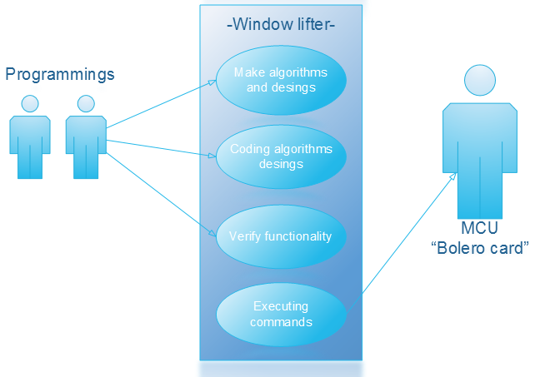

*Use diagram (Microcontoller bolero card)

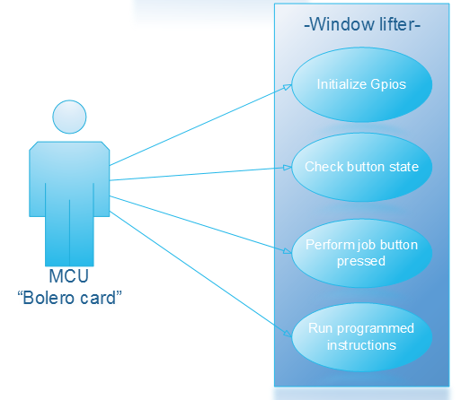

*Use diagram (MCU)

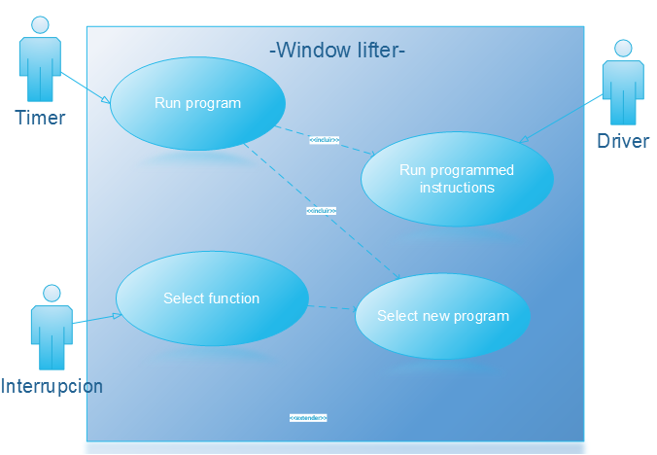
*Deployment Diagram (Window lifter)

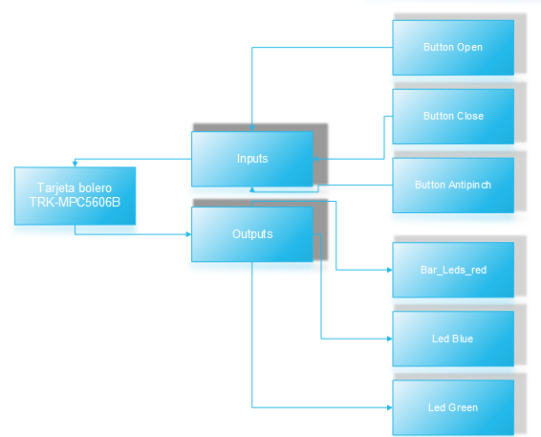

*Blocks diagram

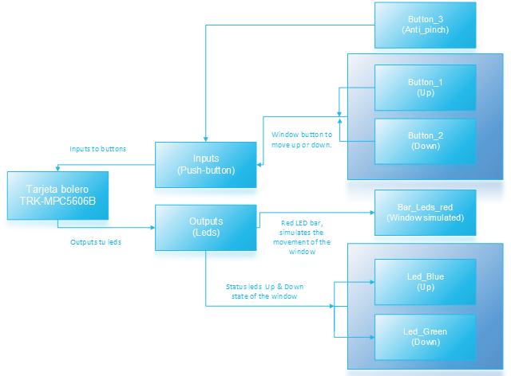
*Component diagram

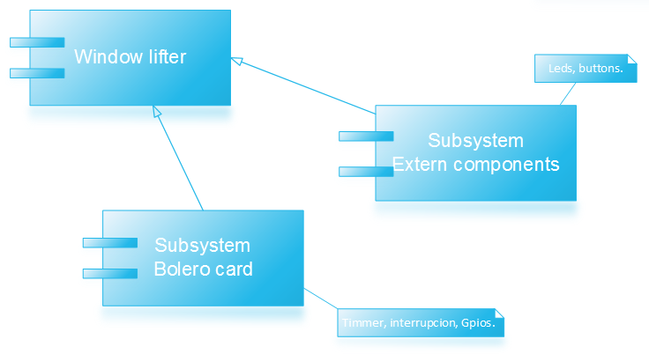

*Activity diagram

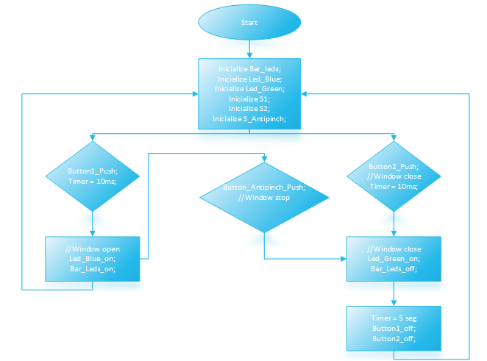

*Class diagram general

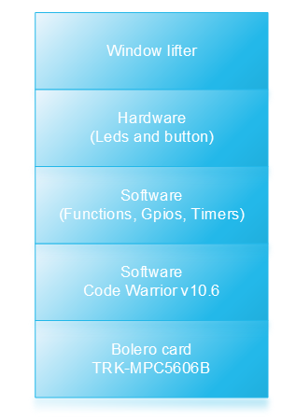

*Class diagram
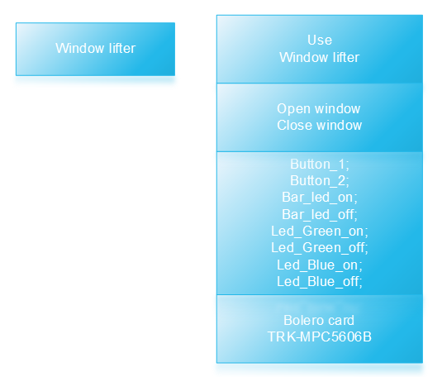

*Colaboration diagram

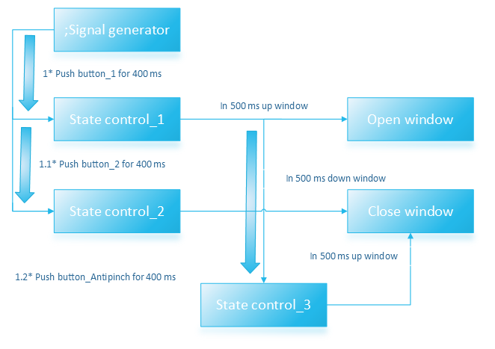

SW Component internal breakdown
For complex SW Components, the designer may define SW Subcomponents. Please consider also the work step "Deal with complexity" provided by the method for Detailed SW Design.
Note: SW Subcomponents are synonymous with the previous used term "Module"
Mapping to the file structure:
- Non complex SW Components should be represented by one object file.
- For complex SW Components each SW Subcomponent should be represented by one object file.
<Subcomponent decomposition if applicable>

Functional Decomposition
Overview of functions and their dependencies shown by a Static Function Tree
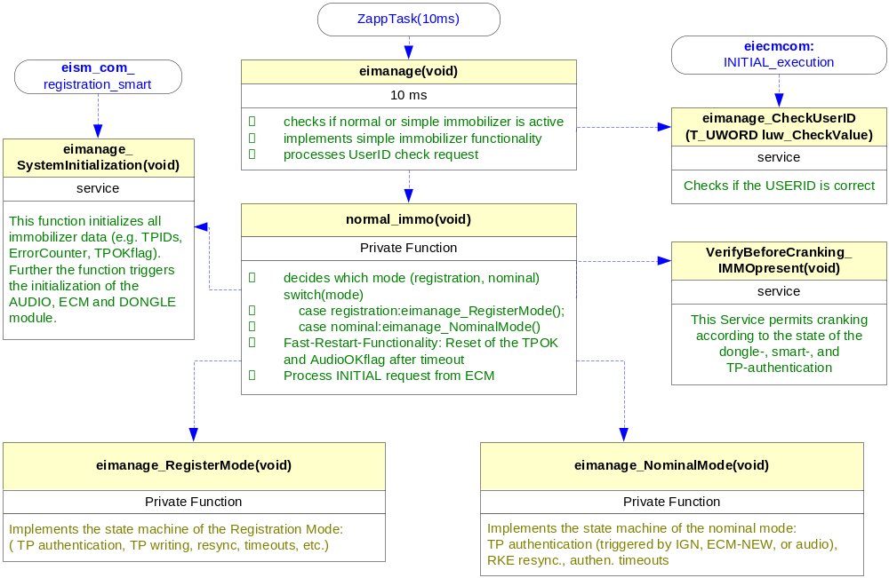
Function Description and Dynamic Behavior
Provide detailed static and dynamic description of all functions of the SW Component.
Functions which are defined in other SW Components shall only be referenced in the external interface description!
The signature description shall be done inside the function header in the source code.
For each function, the following section should be copied

Function <Type> <function name> (type par 1, .., type par n)

Description | Brief description of the function behavior and useful remarks
Parameter 1  <input| output| inout> | Give an explanation if the parameter shall be checked by the user, or if a check is implemented in the function here
Parameter 2..n
Return Value
Precondition | e.g. Function can only be called in a certain state, SW component is initialized  Relation between input parameters where applicable (Input for Module Test)
Post condition | e.g. specific State change e.g. car is locked, EEPROM Values written,  Relation between output parameters where applicable
Error Conditions

Dynamic Behavior
State Chart¹, Flow Chart¹
¹ Preferred
In this document, the dynamic behavior shall be designed on an abstract level showing the principle workflow of a function. Do not show the detailed implementation to ensure that the design description can be maintained with a reasonable effort. The target is not to show the complete detailed implementation 1:1.
The detailed design shall reflect in detail what a function is doing from a black box view. The internal details are useful on an abstract, but not very detailed level.
If the function is not complex a short textual description might be sufficient and a graphical description is not needed.
Symbol and function names shall be self explaining.
The link to the implementation may be provided by using the same names as in the design or by a comment showing the full name followed by the declaration showing the implementation.

Function <Type> <function name> (type par 1, .., type par n)
Description | Brief description of the function behavior and useful remarks
Parameter 1
<input| output| inout>
Parameter 2..n
Return Value
Precondition | e.g. Function can only be called in a certain state, SW component is initialized  Relation between input parameters where applicable (Input for Module Test)
Post condition | e.g. specific State change e.g. car is locked, EEPROM Values written,  Relation between output parameters where applicable
Error Conditions

Dynamic Behavior
State Chart¹, Flow Chart¹, Nassi Shneiderman
¹ Preferred
*diagram de estados////diagramas de actividad*In this document, the dynamic behavior shall be designed on an abstract level showing the principle workflow of a function. Do not show the detailed implementation to ensure that the design description can be maintained with a reasonable effort. The target is not to show the complete detailed implementation 1:1.
The detailed design shall reflect in detail what a function is doing from a black box view. The internal details are useful on an abstract, but not on a very detailed level.
Symbol and function names shall be self explanatory.
The link to the implementation may be provided by using the same name as in the design or by a comment showing the full name followed by the declaration showing the implementation.

